Evaluating end-to-end continuous antibody manufacture with column-free capture alternatives from economic, environmental and robustness perspectives
Catarina P. G. Neves¹, Jonathan L. Coffman², Suzanne S. Farid^{1*}

¹The Advanced Centre for Biochemical Engineering, Department of Biochemical Engineering, University College London, Gower Street, London WC1E 6BT
²Bioprocess Technologies and Engineering, Biopharmaceuticals Development, R&D, AstraZeneca, Gaithersburg, USA

* Corresponding author
Prof. Suzanne S. Farid
s.farid@ucl.ac.uk
+44 20 7679 4415

Abstract
Process intensification efforts have renewed interest in the potential of end-to-end continuous manufacture with column-free capture alternatives. This paper describes a decisional tool that encompasses mass balance and design equations, process economics, stochastic simulation and multi-criteria decision-making and enables the evaluation of different batch and continuous flowsheets for monoclonal antibody (mAb) manufacture. The traditional batch process was compared to end-to-end continuous bioprocesses with either protein A capture or column-free capture employing aqueous two-phase extraction or precipitation from economic, environmental and robustness perspectives. The COG analysis predicted that continuous flowsheets could offer substantial cost savings (~20-40%) over the batch process at low and medium annual commercial demands (100-500 kg); however, at tonnage demands they resulted in either comparable or higher costs. Comparing the continuous options, the continuous flowsheets with protein A or precipitation yielded similar COG/g values, while aqueous two-phase extraction presented higher costs. The analysis of overall process mass intensities accounting for water and consumables suggested that the continuous flowsheet with protein A would result in the lowest environmental burden. When the economic, environmental and operational criteria were reconciled using multi-criteria decision-making analysis, the continuous protein A-based flowsheet was found to be the most favourable. A target analysis highlighted the need for process improvements in the following parameters to reduce the manufacturing costs of the continuous column-free capture options below that of protein A: the perfusion volumetric productivity, the harvested cell culture fluid percentage in column-free operations, the column-free step yields along with the implementation of buffer concentrates.

Keywords: monoclonal antibody manufacturing, protein A chromatography, aqueous two-phase extraction, precipitation, process economics, cost of goods

Introduction
The biopharmaceutical sector has demonstrated sustained progress in addressing the gaps that would enable a shift from batch to integrated continuous bioprocesses, driven by the desire to increase productivity and flexibility while reducing costs (e.g., Konstantinov and Cooney, 2015; Schofield, 2018; Mahal, Branton and Farid, 2021; Rathore, Thakur and Kateja, 2023). Net zero ambitions are also encouraging the sector to consider more sustainable and greener processes (BioPhorum, 2023), and continuous manufacturing has the potential to act as an enabler for smaller facility footprints that may facilitate achieving these targets. Examples include recent investments in continuous processing plants for biologics production by both biopharma companies (e.g., Sanofi, Framingham, MA) and contract development and manufacturing organizations (e.g., Fujifilm Diosynth Biotechnologies, Billingham, UK) (Stanton, 2019a, 2019b). As monoclonal antibodies (mAbs) represent the fastest growing biopharmaceutical market segment, these have also been the prime testbed for continuous manufacturing. Process intensification efforts have renewed interest in using continuous column-free alternatives for mAb capture with the aim of eliminating the high upfront costs associated with protein A resins. However, while technical evaluations of continuous column-free processes in mAb production have been widely reported (e.g., Jungbauer, 2013; Rosa et al., 2013; Kateja et al., 2016; Burgstaller and Satzer, 2019), the assessment of economic, environmental and robustness perspectives to support decision-making is limited. This article describes the investigation of several mAb production flowsheets using a decisional tool that encompasses not only cost of goods (COG) analysis, but also the calculation of environmental, operational and robustness metrics for batch and continuous flowsheets, allowing for a more comprehensive analysis of the trade-offs associated with both column-based and column-free options.
A number of studies have explored the economics of batch versus continuous processes for mAbs with the standard protein A (ProA) capture. These include decisional tools studies using bespoke algorithms and software (e.g., Pollock et al., 2013a and b, 2017; Mahal, Branton and Farid, 2021) and studies with off-the-shelf software (e.g., Walther et al., 2015; Pollard et al., 2016; Gupta et al., 2021). These papers have highlighted fixed capital investment (FCI) and COG savings with continuous processes, with the latter ranging between 10 and 65%, and addressed the nuances between hybrid and end-to-end continuous flowsheets at different production scales.
Interest in column-free alternatives to protein A (ProA) chromatography for mAb capture has been cyclical over the years with recent focus on their potential when operated in continuous mode. In spite of the renewed attention given to continuous column-free options, such as membrane chromatography, flocculation, precipitation and aqueous two-phase extraction, there is a lack of a clear business case for the implementation of such techniques in large scale. This is further complicated by the relatively low technology readiness and maturity levels of continuous manufacturing, and especially continuous downstream processing. The decisional tool described in this article was designed to assess the implementation of aqueous two-phase extraction (ATPE) and precipitation (PP) and to help determine how these can compete with standard ProA chromatography in end-to-end continuous mAb production.
The growing interest in ATPE in mAb processing is linked to its high biocompatibility with biomolecules (phases are 80 to 90% water), high capacity and ease of scaling-up (Rosa et al., 2010; Iqbal et al., 2016). Recovery yields higher than 80% and purities higher than 97% have been reported in continuous mode (Rosa et al., 2011). Also, continuous precipitation in a coiled flow inverter reactor was presented as a viable mAb capture technique, with a recovery yield higher than 95% for the step in batch mode (Kateja et al., 2016, 2018). In continuous mode, the trend has been to use this technique to precipitate the product (instead of impurities) and the step recovery yields and purity are also above 95% (Burgstaller and Satzer, 2019; Li et al., 2019). Cost studies have evaluated hybrid batch/continuous processes with either continuous ATPE (Rosa et al., 2011) or continuous precipitation (Cataldo et al., 2020) in mAb bioprocessing. However, further research regarding the potential of column-free technologies integrated in a fully end-to-end continuous process with GMP equipment is needed, as well as a fair comparison with the current state-of-the-art of continuous protein A chromatography-based capture. Moreover, companies need more systematic methods to assist with decision-making that embrace several perspectives as they endeavour to balance enhanced technical performance with the resultant impact on costs, environmental metrics and operational ease of implementation.
This article presents the application of a decisional tool designed to execute detailed mass balances and facility sizing based on relevant academic and industrial technical data and assumptions for continuous manufacturing with column-based and column-free mAb capture steps and combines a multitude of evaluation perspectives. The tool was applied to a set of industrially-relevant case studies that address the following topical questions: “How does cost of goods compare for batch and continuous mAb flowsheets?”, “Are there environmental benefits moving from batch to continuous processing and column-based to column-free mAb capture?”, “How does batch-to-batch variability influence the robustness of different flowsheets?” and finally “What process improvements are required to decrease the costs of column-free alternatives?”. This study and the predictive modelling results bring transparency to the assessment of the potential of newer technologies integrated in a fully continuous mAb production process.

Materials and Methods

Decisional tool description
A decisional tool was built in Python to model the economic, environmental and operational features associated with different mAb production flowsheets. The tool integrated algorithms for bioprocess economics, environmental analysis, uncertainty analysis via Monte Carlo simulation and multi-criteria decision-making. The tool structure, database and process economic equations built on previous UCL work (Farid et al., 2000; Stonier et al., 2012; Pollock, Ho and Farid, 2013; Mahal, Branton and Farid, 2021). The tool to model end-to-end continuous bioprocesses presented by Mahal (2021) was extended to integrate the following new features: i) mass balance and design equations for aqueous-two phase extraction and precipitation; ii) equipment costs and default process parameter values for column-free capture operations and; iii) calculations for environmental metrics with an updated database including masses of consumables. Table 1 depicts the key economic and environmental equations featured in the tool as well as the key process parameters. The fixed capital investment (FCI) was computed using the Lang factor and the total equipment purchase cost. The cost of goods (COG) comprised direct (reagents, consumables, labour and quality control materials) and indirect (depreciation and facility-dependent overheads) costs. The tool determined the process mass intensity (PMI) indicators as environmental metrics; PMI was defined as the total mass of waste generated per total mass of product, categorised into water waste and consumables waste. Water waste was categorized further into process water (e.g. cell culture media and process buffers) and non-process water (e.g. CIP and SIP). The tool used a multi-criteria decision-making technique to combine the tool’s financial and environmental metrics with operational metrics such as ease of scale-up.

Sensitivity and uncertainty analysis methodology
One-way sensitivity analyses were used to identify the key COG drivers. These were then used in the Monte Carlo simulations. The Monte Carlo simulation algorithm was coded in Python to enable distributions (e.g. triangular) to be applied to the designated input parameters and used a random number generator to create the set of iterations. The algorithm computed the likelihood of the COG output falling below different thresholds. A two-tailed t-test was performed to evaluate whether there was a significant difference between the COG/g distributions of the flowsheets, as indicated by the p-values and a chosen significance level of 0.05. The algorithm was used to perform 100 iterations per run which was found to be sufficient to reach convergence. The number of iterations needed to reach convergence was determined by calculating the mean and standard deviation after each run (from n=2) and monitoring when these values were within a tolerance of 5% from the global mean and standard deviation. The global mean and standard deviation corresponded to the values calculated after 1000 runs.

Multi-criteria decision making (MCDM) methodology
The MCDM technique incorporated in the decisional tool was based on the weighted sum method and was designed to provide an overall measure of attractiveness for each flowsheet that reconciled economic, environmental and operational criteria (Pollock, Ho and Farid, 2013; Pollock et al., 2017). The economic (COG and FCI) and environmental (water and consumables process mass intensities (PMI)) ratings ($x_{ij})$ were directly obtained from the process economics model. The operational criteria identified for the analysis were robustness, ease of validation, ease of installation, ease of scale-up and ease of operation. The relative rating values of each flowsheet at each operational criteria ($x_{ij})$and the rank of importance of each criterion amongst all operational criteria ($E_{i}$) were gathered from a survey questionnaire sent to industry and academic experts on the field. The criteria expressing economic and environmental feasibilities were ranked equally within each criteria category. All rating values were standardised to a common dimensionless scale ($r_{ij})$ between 0 and 100 according to equation 1.
$$r_{ij}= \frac{x_{ij-}x_{iWorst}}{x_{iBest-}x_{iWorst}}×100 (1)$$

The weight of each criterion, $E_{i}$, was based on the rank of importance (most important weighs the most) and was then normalised as $w_{i}$ according to equation 2.
$$w_{i}= \frac{E_{i}}{\sum_{i=1}{E_{i}}} , where Ei=a, a-1,…,1 for rank=1, 2,…,a (2)$$
The weighted score of each flowsheet for each criterion, $y_{jk}$, (i.e. economic, operational and environmental) was derived using equation 3.
$$y_{jk}=\sum_{i=1}^{n}{r_{ij}×w_{i}} (3)$$

The overall aggregated score, $S_{j}$, was computed according to equation 4. The ratios of importance of each criteria category ($R_{k}$) enabled the priorities of the economic, environmental and operational criteria to be altered based on user preferences, where the sum of the $R_{k}$ values was equal to 1 ($R_{eco}+R_{env}+R_{op}=1)$.
$$S_{j}=\sum_{k=1}^{n}{y_{jk}×R_{k}=}y_{j,eco} ×R_{eco}+ y_{j,env} ×R_{env}+ y_{j,op} ×R_{op} (4)$$
$$j:alternative (Conti-ProA, Conti-ATPE, Conti-PP)$$
$$k:criteria category (economic, environmental, operational)$$
$$i:criterion (COG, FCI,PMI, robustness, ease ofvalidation, etc)$$
$$r_{ij}:standardised rating of alternative j in subcriterion i$$
$$x_{ij}:rating value of alternative j in subcriterion i$$
$$x_{iWorst/Best}:{Worst}/{Best} rating value for subcriteron i among all alternatives$$
$$w_{i}:normalised weight of criterion i in category k$$
$$E_{i}:weight of criterion i in category k (based on rank)$$
$$a:number of rankings$$
$$y_{jk}:weighted score of each alternative j in category k$$
$$S_{j}:overall aggregated score of alternative j$$
$$R_{k}:ratio of importance of criteria k$$

mAb production flowsheets
The tool was used to model and evaluate commercial mAb facilities using different production strategies across different annually required product demands. The case studies explored three antibody capture technologies: protein A affinity chromatography (ProA), aqueous two-phase extraction (ATPE) and product precipitation (PP). Figure 1 shows the flowsheets modelled in the decisional tool.
While Batch-ProA depicted a typical fed-batch process, the continuous flowsheets integrated a perfusion bioreactor that enabled the retention of the cells inside the bioreactor and, therefore, did not require centrifugation and depth filtration as primary recovery steps before mAb capture. The simulation of the batch and continuous flowsheets integrating protein A chromatography was described by Mahal, Branton and Farid (2021). In this paper, in Conti-ATPE and Conti-PP, only the capture stage was re-designed, thus, the process modelling from the viral inactivation to the final inline diafiltration was kept as described by Mahal, Branton and Farid (2021).
For the capture stage, the multicolumn protein A chromatography modelled in Conti-ProA was replaced with multiple steps in Conti-ATPE and Conti-PP. In Conti-ATPE, the aqueous two-phase extraction takes place in a glass column and the operation occurs countercurrently, where the top PEG-rich phase is continuously fed at the bottom of the column, while the bottom salt-rich phase is fed at the top of the column (Rosa et al., 2012). The product is recovered from the top PEG-rich phase. As the extraction led to a dilution of the stream, a concentration step (single-pass filtration) was included afterwards to concentrate the product phase. A subsequent diafiltration step was added for buffer exchange and removal of the PEG from the system before the viral inactivation.
In Conti-PP, the harvested cell culture fluid (HCCF) and zinc are continuously fed to a static mixer, where product precipitation occurs inline. A second static mixer was placed in series, to which PEG is added to promote the growth of precipitates (Li et al., 2019). The precipitates were then concentrated, washed and re-concentrated in a single continuous filtration unit to decrease the number of equipment required. After an in-line resolubilisation in another static mixer, a depth filtration was also included to avoid solid particles entering the remaining DSP. Before the viral inactivation, an extra concentration step was modelled to achieve the target concentration. All design equations are summarised in the supplementary material.
All batch and continuous process trains were designed to produce 100 to 1000 kg per year. The cell culture size was calculated based on the annual demand required and on the overall yields computed for the DSP train in each flowsheet. Bioreactor sizes were adjusted based on vendor constraints with a maximum size of 20,000L for stainless steel bioreactors and 2000L for single-use bioreactors. The single-use based continuous production flowsheets (Conti-ProA, Conti-ATPE and Conti-PP) were compared with the reference batch stainless-steel facility type with protein A chromatography as capture step (Batch-ProA). For Batch-ProA, the equipment sizing was based on the mass entering each unit operation and all steps were carried out sequentially. For the continuous options, the sizing was based on the outlet flowrate of the previous unit operation in the process train and the end-to-end continuous process was achieved through keeping the product outlet and inlet flows between units constant to avoid surge vessels or hold-times. When sizing the continuous ATPE glass column, the height was kept constant, whilst for continuous precipitation the length of the static mixers (Li et al., 2019) was kept constant. The sizing equations of the chromatography column, ATPE extractor and precipitation static mixers can be found in Table 1.

Case study assumptions

Process parameters
Table 1 summarises the key input assumptions for each flowsheet. A 14-day fed-batch process with a 5 g/L titre was compared with a 28-day perfusion in the continuous mAb production strategies. For continuous perfusion, the product collection starts only after the initial growth and ramp‐up phase of 8 days and a 7-fold increase in volumetric productivity (3 g/L/d) was assumed over batch. For continuous multicolumn chromatography, higher resin loading capacities (ProA DBC=65g/L resin, AEX DBC=100g/L resin, CEX DBC=100g/L resin) were assumed given the better resin capacity utilization compared to batch (Pollock et al., 2013; Jagschies, 2018). The binding capacities and prices for protein A resin in the different modes were selected to reflect the latest industry benchmarks.
For continuous ATPE and continuous precipitation, the percentage of HCCF (percentage of the final volume in the ATPE/PP system corresponding to the perfusion broth volume after adding the other components, such as PEG or salt) was assumed as 18 (Rosa et al., 2012) and 50% (Li et al., 2019), respectively. The yield of continuous ProA chromatography in Conti-ProA was set as 95%, while the base case recovery of the ATPE step was 85% (Rosa et al., 2012) and the wash yield in Conti-PP was 82% (Li et al., 2019). The resulting overall DSP yields were of 70, 60 and 55% for Conti-ProA, Conti-ATPE and Conti-PP, respectively. The product concentration prior to the viral inactivation step in Conti-ATPE and Conti-PP was set as the same found after protein A chromatography in Conti-ProA (32 g/L), so the size and time of the polishing stage would be kept constant across continuous flowsheets.
Some authors have shown comparable purity (Azevedo, Rosa and Ferreira, 2008; Rosa et al., 2012) when using alternatives to ProA chromatography in mAb capture, others state further work is required to improve impurity removal (Li et al., 2019). In this paper, the economic potential of the flowsheets was explored on the basis that all flowsheets are able to meet the target purity specifications.
The batch and continuous labour requirements are as described by Mahal, Branton and Farid (2021) and 3 shifts per day are assumed with 6 operators per USP and per DSP shifts in Batch-ProA and 3 operators per USP and per DSP shifts in Conti-ProA, Conti-ATPE and Conti-PP. In this paper, the definition of “batch” in the continuous flowsheets is taken as the quantity of product delivered per cell culture run (10 batches per year). Similarly to what is described in Mahal, Branton and Farid (2021), as a quality control batch release test in continuous is performed every four days on the material collected in that period of time, there are 5 “QC batches” per perfusion culture, which is taken into account when calculating the QC costs (35k$ per batch release test).
In the present model, all process buffers were purchased for a fixed cost (no buffer preparation in-house). In single-use facilities, these buffers are stored in single-use bags (maximum capacity of 5000 L) and bag containers and trolleys are required to hold them in place where needed throughout the process train. These containers were considered in the indirect costs as part of the equipment purchase cost used in the calculation of the fixed capital investment.

Uncertainty assumptions
Typical cell culture titre fluctuations are of ±20% (Pollock, Ho and Farid, 2013). This variation was also applied to the dynamic binding capacity (DBC) of protein A, as a way of simulating the influence that different required quantities of expensive resin could have on the cost of goods. The specific column-free alternatives’ parameters and ranges were discussed with experts in these technologies. Variations at the cell culture tire or volumetric productivity were translated into smaller/bigger/more/fewer bioreactors required and smaller/larger media consumption. The same effect was seen when considering uncertainty in the process step yields, as the USP was redesigned to compensate for the product gain/loss during the downstream processing. The variation of the HCCF percentage in ATPE and PP impacted the dilution of the broth coming from perfusion, thus, the burden on the concentration steps required before the virus inactivation.

Results
The attractiveness of batch and continuous manufacturing strategies with different capture technologies was assessed using a decisional tool that captured the nuances of different modes of operation and different technology choices. The cost analysis was extended by evaluating each process’s environmental burden and using stochastic uncertainty analysis to assess the robustness of the different scenarios under inherent process variability. An MCDM analysis was used to weigh up the financial, environmental and operational attributes of each flowsheet. A final target analysis highlighted the process changes needed for alternative production strategies to become cost-competitive.

Deterministic COG analysis of batch and continuous mAb processes with different capture technologies
The COG/g outputs from the deterministic analysis conducted with the decisional tool are shown in Figure 2a on a cost category basis for the batch and continuous mAb flowsheets. This figure shows that the continuous production flowsheets, whether ProA-based or column-free (Conti-ProA, Conti-ATPE and Conti-PP) could offer COG savings of ~20-40% compared to the standard batch flowsheet (Batch-ProA) at lower and medium scales (100 and 500 kg/year). In contrast, at higher scales (1000 kg/year) only Conti-ProA and Conti-PP presented a similar or slightly lower COG than Batch-ProA.
The cost savings with continuous flowsheets relative to batch at low and medium scales were driven by savings in indirect and reagent costs. The decrease in indirect costs can be attributed to the smaller equipment needed in continuous mode given the higher cell culture productivities; e.g. at 500kg/year the indirect costs change from 56$/g for Batch-ProA to 25$/g for Conti-ProA, 31$/g for Conti-ATPE and 24$/g for Conti-PP. The savings in equipment costs switching from Batch-ProA to the continuous flowsheets could go up to 50% for 7-fold productivity differences. Also, as shown in Figure 2b, the savings associated with the absence of CIP cleaning procedures in SU facilities outweighed the 2 to 3-fold higher media consumption found for perfusion bioreactors and led to a 10 to 60% cost reduction in reagents across scales and flowsheets (e.g. 500kg/year reagents costs: 27$/g Batch-ProA, 21$/g Conti-ProA, 25$/g Conti-ATPE, 26$/g Conti-PP). The savings in indirect and reagent costs were more significant than the increase in consumables costs (up to 2-fold) when using single-use continuous flowsheets (e.g. 500kg/year consumables costs: 7$/g Batch-ProA; 11$/g Conti-ProA; 13$/g Conti-ATPE, 10$/g Conti-PP).
Turning to the comparison at the higher 1000 kg/year demand, the lower COG savings with the continuous flowsheets were due to the need for multiple (two) parallel production trains. As the capacity of the SU bioreactor bags is limited (2000L), when more than one bioreactor was required, an additional dedicated DSP train was simulated in parallel. At 1000 kg/year, Conti-ProA and Conti-PP presented COG savings of 8% and 3%, respectively, compared to Batch-ProA, which were not so significant given the typical accuracy of cost estimates. Due to the comparable indirect costs and higher consumables costs of Conti-ATPE compared to Batch-ProA at high scale, the ATPE-based flowsheet showed a COG/g increase of more than 10% compared to the batch case; this was the only scenario where a continuous flowsheet was found to perform worse than the batch flowsheet.
The cost comparison among continuous flowsheets in Figure 2a also showed that Conti-ProA was the strategy offering the lowest COG/g across scales, followed closely by Conti-PP (2-6% higher COG). Conti-ATPE presented the highest COG/g (8-22% higher COG than Conti-ProA) amongst all continuous flowsheets. For Conti ATPE, all cost categories were higher than Conti-ProA. This is mainly attributed to the HCCF dilution that drives up equipment costs (bag containers and filtration skids), consumables (SU bags) and reagents (ATPE-specific buffers and diafiltration buffers). For Conti PP, the overall cost was similar or slightly higher than Conti-ProA. While the reagents costs were 24% higher, driven by the larger media volumes (30% higher media costs than Conti-ProA), the consumables costs were lower (9-14%), mainly due to the absence of ProA resin, and the total equipment purchase cost was similar.
Figure 3a depicts the COG breakdown by major stage (USP/capture/polishing). This highlights that the steps involved in the capture stage represented a significant proportion of the COG with a base value of ~30% for the conventional batch flowsheet. Moving from the conventional batch flowsheet (Batch-ProA) to continuous flowsheets with chromatography (Conti-ProA) or precipitation (Conti-PP) resulted in a reduction in the contribution of the capture stage to the overall COG from ~30% to <25%. In contrast, the continuous ATPE flowsheet (Conti-ATPE) resulted in a higher contribution of the capture stage to the overall COG than any of the other strategies (37-44%).
The cost category distributions by stage were investigated further, focusing on the stages most affected by the change in strategy – USP and capture. For the capture stage, both batch and continuous processes were dominated by the indirect costs that consumed over 50% of the capture COG; hence for capture stages, changes in capital equipment would have a larger impact than changes in materials such as the resin. In contrast, for the USP stage, the move from batch to continuous flowsheets resulted in a shift in the USP COG distribution from being dominated by USP indirect costs (50%) in batch processes to USP materials (~70-80%, predominantly culture media reagents) in continuous processes.

Environmental analysis of batch and continuous mAb processes with different capture technologies
The potential environmental benefits moving from batch to continuous and from column-based to column-free mAb capture were evaluated by analysing the environmental burden associated with each mAb flowsheet. The process mass intensities (PMIs) are shown in Figure 4 and are split into water and consumables PMI for the different production strategies. Continuous flowsheets offered a significant reduction in the overall PMI compared to the traditional batch process depending on scale, with Conti-ProA offering the most environmentally friendly strategy of all mAb production strategies. This was driven by the reduction in water PMI that outweighed any increases in consumables PMI since water PMI values were in the order of thousands of kg/kg while consumables PMI were significantly lower and in the order of tens of kg/kg.
Digging deeper into the analysis produces useful PMI benchmark values for the sector. Water PMIs for Batch-ProA were between 5000 and 17,000 kg/kg, while consumables PMIs ranged between 4 and 6 kg/kg, depending on the production scale. According to Figure 4a, the switch from batch to continuous flowsheets can lead to 2-8-fold lower water PMIs from high to low production scales (2200kg/kg Conti-ProA, 3300kg/kg Conti-ATPE, 3600kg/kg Conti-PP across scales). As discussed in the cost analysis, the absence of CIP procedures in continuous single-use based facilities results in significant water savings compared to the batch stainless-steel based strategy. Although the continuous options have a lower water PMI than the batch flowsheet, the continuous column-free options fare worse than the continuous ProA option. The higher water PMIs of Conti-ATPE and Conti-PP compared to Conti-ProA can be attributed to the higher media consumption and diafiltration buffers.
In contrast to the water PMI trends, the consumables PMI in Figure 4b was 4 to 5-fold higher in continuous mode (e.g. 500kg/year consumables PMI: 5kg/kg Batch-ProA, 15kg/kg Conti-ProA, 18kg/kg Conti-ATPE, 16kg/kg Conti-PP). However, the order of magnitude is negligible compared to the lower liquid waste. On the consumables front, as expected from the cost analysis, Conti-ATPE resulted in a higher consumables PMI (SU bags and membranes). Regarding Conti-PP, contrary to the consumables cost savings compared to Conti-ProA, the consumables PMI in Conti-PP was in fact higher than the column-based option. This comes from the higher usage of filters and SU bags that outweigh the reduction in consumables weight (kg) from the absence of Pro-A pre-packed columns. Overall, Conti-ATPE presents a water PMI and a consumables PMI approximately 70% and 20% higher than Conti-ProA, respectively, and Conti-PP presents a water PMI and consumables PMI approximately 60% and 10% higher than Conti-ProA, respectively.
The water and consumables PMI values are within the range of values reported in the literature for continuous mAb flowsheets (Ho et al., 2010; Pollock et al., 2017; Madabhushi et al., 2018; Cataldo et al., 2020) and suggest that continuous and single-use technologies can be key enablers for improving environmental impact in terms of overall PMI.

Robustness evaluation with uncertainty analysis
In every large-scale bioprocess there are inherent uncertainties; thus, it is important to identify the key sources for technical deviations and account for them in the cost model to generate representative results. While the economic and environmental advantages of pursuing Conti-ProA strategy were highlighted during the deterministic cost comparison, a stochastic analysis enabled the evaluation of different scenarios under process variability. The first step was to conduct a sensitivity analysis by changing some critical process parameters in the column-based and column-free capture flowsheets to understand which factors had the largest influence on mAb production costs and to identify the major risks or benefits for production in terms of process changes. The selected ranges presented were discussed with academic and industrial partners, so the analysis could fairly represent the best and worst technical parameters found for each one of the technologies.
The results of the sensitivity analysis are illustrated in the tornado diagrams in Figure 5. The diagrams illustrate that the key COG driver is the titre (in Batch-ProA) and volumetric productivity (in Conti-ProA/ATPE/PP) in cell culture. Lower titres/productivities than expected resulted in higher USP costs as larger or more bioreactors were required to meet the demand. This had a knock-on impact on total reagent costs, dominated by CIP buffer costs in Batch-ProA (58%) and media costs in the continuous strategies (>75%). On the other hand, working with increased volumetric productivities and more concentrated HCCF would benefit specially the column-free alternatives, as lower perfusion volumes would require a smaller DSP. Figure 5c and Figure 5d show that the HCCF percentage was the second parameter with the largest impact on the cost of goods in both column-free capture alternatives. The HCCF% in the ATPE or PP systems’ composition determined the dilution of the broth and the volume handled in the following steps. Therefore, changes at this level had a large impact on the equipment investment (associated with the indirect costs), consumables and reagents costs. In Conti-ATPE, an increase from 18% to 25% of perfusion liquid in the ATPE system (HCCF%) could decrease the final COG/g by more than 10% at medium and large scales, demonstrating the benefits of a lower product dilution on the cost-effectiveness of liquid extraction for mAb capture.
The concentration of buffers was also a factor to be considered when looking at process changes that could reduce costs in column-free strategies. As the bag containers dominate the equipment costs for the capture sequence in Conti-ATPE and Conti-PP, using buffer concentrates and inline dilution would bring savings in the final cost of goods. Other changes in parameters such as the reagents’ price, filtration fluxes, or other equipment price (besides capture EPC) had a lower impact on the final COG/g; thus, they are not considered to portray significant risks for the process. The individual parameter changes that resulted in greater than a 5% change in COG were selected and integrated into the uncertainty analysis using Monte Carlo simulations, where the process mass output was fixed (100, 500 and 1000 kg/year) and the facility was resized for each iteration to reflect the consequences of different starting assumptions.
Accounting for key uncertainties in the batch and continuous processes with a stochastic analysis enables the robustness of the options to be determined as well as the likelihood of meeting certain COG/g threshold values. The results of the stochastic Monte Carlo analysis are depicted in the COG frequency distributions in Figure 6 with an embedded table of key statistics. The figure shows that Conti-ProA presented the most robust alternative across demands compared to the batch and continuous column-free options as indicated by its narrower distribution and lowest standard deviation and hence risk. It had also the lowest expected cost and the differences in COG distributions were found to be statistically significant, as indicated by all p-values being below 0.05 (embedded table). Of the column-free options, Conti-PP had the higher probability of matching Conti-ProA expected COG values, with a likelihood ranging from 10 to 30% across scales (embedded table). Bimodal distributions, with peaks occurring at different COG values for the same alternative and scale, were observed for Batch-ProA at 100 kg/year and Conti-PP at 500 kg/year, when there was a jump in bioreactor scale due to low titre or productivity, respectively. Apart from this scenario, uncertainties in titres, process yields, HCCF% or binding capacities did not represent major shifts in the most likely COG/g for each flowsheet (peaks from stochastic distributions are within 5% of costs attained in the deterministic analysis, as shown in the embedded table).

Multi-criteria decision making
MCDM analysis was used to reconcile economic, environmental and operational criteria and identify the most advantageous continuous strategy considering all perspectives. While the economic (COG/g and FCI) and environmental (water and consumables PMI) criteria were directly obtained as model outputs, the qualitative criteria (e.g., ease of scale-up, ease of validation) were derived from survey responses from academia and industry experts with experience in affinity chromatography, liquid-liquid extraction and precipitation used in mAb capture. Table 2 summarises the key values used in the MCDM to compute the overall aggregate scores for each flowsheet (ProA chromatography, ATPE and PP), including the criteria weights, standardised ratings and weighted category scores. From the list of qualitative operational criteria, robustness was the most important metric, while ease of installation ranked last, based on the survey responses. The radar chart in Figure 7a shows all standardised rating values for each criteria for each flowsheet and it was used to simplify the visualisation of the preferred flowsheet at each criteria. As expected, Conti-ProA scored the highest in all economic and environmental criteria. Moreover, it had the maximum score in two out of five operational criteria, including robustness, the most important metric. Conti-ATPE had very poor scores across all quantitative metrics due to its high COG/g, equipment cost, consumable usage and water consumption; however, its operational feasibility was reasonably high according to the qualitative scores given by experts. Conti-PP scored well in the economic criteria, whereas, operational-wise, it only showed high scores for the two least important criteria (ease of operation and installation).
To reconcile the competing outputs, the overall aggregate score was generated for each flowsheet across different combination ratios of the economic, environmental and operational categories (Figure 7b and c). The resulting sensitivity spider plots illustrate how the ranking of the alternative continuous options changes depending on user priorities. The figures clearly illustrate that Conti-ProA was the preferred continuous strategy irrespective of the relative importance of the economic, environmental or operational category scores. The ranking between the remaining column-free options of Conti-PP and Conti-ATPE depended on the weightings of the categories. When economic and environmental performance were prioritised, Conti-PP was preferred over Conti-ATPE for all combinations of these two categories (Figure 7b). However, when operational performance was brought into the picture as a key priority (Figure 7c) and weighed against economic savings, then a switch point occurred where the operational category was twice as important as the economic category ($R_{op}=0.6, R_{eco}=0.3)$. When the operational benefits dominated in the final score above this threshold ($R_{op}>0.6)$then Conti-ATPE become the preferred column-free option over Conti-PP.

Target analysis
The earlier COG analysis in this article showed that the continuous mAb facilities modelled with column-free capture technologies did not offer lower manufacturing costs compared to the column-based option (Conti-ProA). This section determines the cost reductions required for column-free alternatives to achieve a target COG saving threshold of at least 15% compared to the continuous flowsheet with ProA capture to justify the process change. The ATPE and PP process changes implemented were based on the parameters that had the highest impact on COG/g savings in the sensitivity analysis, namely the perfusion volumetric productivity with either the ATPE HCCF% or the PP wash yield.
Figure 8 displays the target analysis as a matrix of heatmaps across scales and buffer preparation methods to determine the windows of operation where parallel improvements in ATPE and PP flowsheets result in COG savings that meet the target threshold of 15% (highlighted by the region within the black solid lines).
With traditional buffer preparation, the target COG saving was not achieved regardless of the combination of parameters in the column-free flowsheets. Also, in Conti-ATPE, possible increases in volumetric productivity or HCCF fraction rarely led to COG values matching Conti-ProA COG. On the other hand, in Conti-PP, as the base-case COG is already very similar to Conti-ProA, changes in these process parameters led to scenarios offering modest savings over ProA chromatography.
The implementation of inline dilution of buffers (2-fold buffer concentrates) across all options conferred a strong advantage particularly for both Conti-ATPE and Conti-PP. The target COG saving could be reached for a broad combination of parameters in Conti-ATPE and Conti-PP. The window of feasible combinations meeting the target increased as scales increased due to the larger contribution of consumables and reagents costs to the total COG at higher scales and the ability of the process changes to minimise material consumption.
The attractiveness of Conti-ATPE and Conti-PP will depend on the improvement of multiple process parameters to levels that may be beyond the current best cases found in literature. The usage of buffer concentrates is becoming more commonplace and improved perfusion volumetric productivities may be envisioned for the near future. Also, the implementation of a simple pre-concentration step before capture has been already discussed with partners and it would resemble the benefits of having higher volumetric productivities, as working with a more concentrated HCCF would lead to smaller volumes during DSP. However, increasing the HCCF percentage in the ATPE/PP systems without compromising capture performance and achieving higher step yields would entail further studies on the technical optimisation of aqueous two-phase extraction and precipitation as capture technologies applied to monoclonal antibodies.

Conclusion
This paper presented the extent of capabilities configured in a process economics model that enabled the comparison of different mAb production flowsheets from economic, environmental and robustness perspectives. The simulation tool built in Python was used to design batch and continuous facilities and provided an in-depth evaluation of the trade-offs associated to protein A chromatography, aqueous two-phase extraction and product precipitation as mAb capture steps across production scales. The cost drivers for each scenario were highlighted and determined that the implementation of continuous manufacturing was preferable over batch, especially at lower scales, and that the broth dilution in ATPE and higher media consumption in PP could favour the selection of ProA as capture step in continuous mAb processing. Although there was an increase in consumables usage in continuous mode, the environmental analysis showed that the water savings found over batch would decrease the overall environmental burden associated with continuous mAb production. The multi-criteria decision making analysis presented higher aggregate scores for continuous mAb processing with column-based capture across scenarios with different weightings for economic, operational and environmental performance. The target analysis showed that ATPE and PP could provide lower cost of goods than ProA if buffer concentrates are implemented and if the cell culture volumetric productivity, the HCCF% in the ATPE system and precipitates wash yields were maximised altogether. The added value of such a simulation framework was revealed through the assessment of different technologies, flowsheets and scenarios, as these are critical during process development and decision-making on future facility designs in the biopharmaceutical sector.

Acknowledgments
The authors would like to thank Ana Azevedo (Técnico Lisboa) for sharing her knowledge and for providing relevant inputs to the project. The acknowledgment is extended to the following industrialists and academics who answered the survey sent on the operational capabilities of different mAb capture technologies: Mario A. Torres-Acosta (University College London), Marco Rito-Palomares (Escuela de Medicina y Ciencias de la Salud, Tecnológico de Monterrey), Andrew Zydney (Penn State University), Alois Jungbauer (Austrian Centre Industrial Biotechnology), Michael Hoare (University College London) and Anurag Rathore (Indian Institute of Technology Delhi). This study was supported by the CODOBIO project funded by the Horizon 2020 Marie Sklodowska‐Curie Action ITN 2017 of the European Commission (H2020‐MSCA‐ITN‐2017. Grant number: 812909). This research is associated with the joint UCL-AstraZeneca Centre of Excellence for predictive decision-support tools in the bioprocessing sector and is aligned with the EPSRC Future Targeted Healthcare Manufacturing Hub hosted by UCL Biochemical Engineering.

Conflicts of interest
The authors report no conflict of interest.

Data Availability Statement
The data that supports the findings of this study are available in the supplementary material of this article.

References
Azevedo, A. M., Rosa, P. A. J. and Ferreira, I. F. (2008) ‘Integrated process for the purification of antibodies combining aqueous two-phase extraction , hydrophobic interaction chromatography and size-exclusion chromatography’, Journal of Chromatography A, 1213, pp. 154–161. doi: 10.1016/j.chroma.2008.09.115.
BioPhorum (2023) ‘Biophorum Environmental Sustainability Roadmap 2022’. doi: https://doi.org/10.46220/2022SUST001.
Burgstaller, D. and Satzer, P. (2019) ‘Continuous integrated antibody precipitation with two ‐ stage tangential flow microfiltration enables constant mass flow’, pp. 1053–1065. doi: 10.1002/bit.26922.
Cataldo, A. L. et al. (2020) ‘Economics and ecology : Modelling of continuous primary recovery and capture scenarios for recombinant antibody production’, Journal of Biotechnology. Elsevier, 308(June 2019), pp. 87–95. doi: 10.1016/j.jbiotec.2019.12.001.
Farid, S. S. et al. (2000) ‘A tool for modeling strategic decisions in cell culture manufacturing’, Biotechnology Progress, 16(5), pp. 829–836. doi: 10.1021/bp0001056.
Gupta, P. et al. (2021) ‘Economic assessment of continuous processing for manufacturing of biotherapeutics’, Biotechnology Progress, 37(2), pp. 1–16. doi: 10.1002/btpr.3108.
Ho, S. V. et al. (2010) ‘Environmental considerations in biologics manufacturing’, Green Chemistry, 12(5), pp. 755–76. doi: 10.1039/b927443j.
Iqbal, M. et al. (2016) ‘Aqueous two-phase system ( ATPS ): an overview and advances in its applications’, Biological Procedures Online. Biological Procedures Online, pp. 1–18. doi: 10.1186/s12575-016-0048-8.
Jagschies, G. (2018) Continuous Capture of mAbs-Points to Consider and Case Studies, Biopharmaceutical Processing: Development, Design, and Implementation of Manufacturing Processes. Elsevier Ltd. doi: 10.1016/B978-0-08-100623-8.00028-1.
Jungbauer, A. (2013) ‘Continuous downstream processing of biopharmaceuticals’, Trends in Biotechnology. Elsevier Ltd, 31(8), pp. 479–492. doi: 10.1016/j.tibtech.2013.05.011.
Kateja, N. et al. (2016) ‘Continuous precipitation of process related impurities from clarified cell culture supernatant using a novel coiled flow inversion reactor ( CFIR )’, Biotechnology Journal, 11, pp. 1320–1331. doi: 10.1002/biot.201600271.
Kateja, N. et al. (2018) ‘Non-protein A purification platform for continuous processing of monoclonal antibody therapeutics’, Journal of Chromatography A. Elsevier B.V., 1579, pp. 60–72. doi: 10.1016/j.chroma.2018.10.031.
Konstantinov, K. B. and Cooney, C. L. (2015) ‘White paper on continuous bioprocessing May 20-21, 2014 continuous manufacturing symposium’, Journal of Pharmaceutical Sciences. Elsevier Masson SAS, 104(3), pp. 813–820. doi: 10.1002/jps.24268.
Li, Z. et al. (2019) ‘Continuous precipitation for monoclonal antibody capture using countercurrent washing by microfiltration’, Biotechnology Progress, 35(6), pp. 1–8. doi: 10.1002/btpr.2886.
Madabhushi, S. R. et al. (2018) ‘Quantitative assessment of environmental impact of biologics manufacturing using process mass intensity analysis’, Biotechnology Progress, 34(6), pp. 1566–1573. doi: 10.1002/btpr.2702.
Mahal, H., Branton, H. and Farid, S. S. (2021) ‘End-to-end continuous bioprocessing: Impact on facility design, cost of goods, and cost of development for monoclonal antibodies’, Biotechnology and Bioengineering, (October 2020), pp. 1–18. doi: 10.1002/bit.27774.
Pollard, D. et al. (2016) ‘Standardized Economic Cost Modeling for Next-Generation MAb Production’, BioProcess International, 14(8), pp. 14–23. doi: 10.4155/pbp.13.46.
Pollock, J., Ho, S. V. and Farid, S. S. (2013a) ‘Fed-batch and perfusion culture processes: Economic, environmental, and operational feasibility under uncertainty’, Biotechnology and Bioengineering, 110(1), pp. 206–219. doi: 10.1002/bit.24608.
Pollock, J. et al. (2013b) ‘Optimising the design and operation of semi-continuous affinity chromatography for clinical and commercial manufacture’, Journal of Chromatography A, 1284, pp. 17–27. doi: 10.1016/j.chroma.2013.01.082.
Pollock, J. et al. (2017) ‘Integrated continuous bioprocessing: Economic, operational, and environmental feasibility for clinical and commercial antibody manufacture’, Biotechnology Progress, 33(4), pp. 854–866. doi: 10.1002/btpr.2492.
Rathore, A. S., Thakur, G. and Kateja, N. (2023) ‘Continuous integrated manufacturing for biopharmaceuticals: A new paradigm or an empty promise?’, Biotechnology and Bioengineering, 120(2), pp. 333–351. doi: 10.1002/bit.28235.
Rosa, P. A. J. et al. (2010) ‘Aqueous two-phase systems: A viable platform in the manufacturing of biopharmaceuticals’, Journal of Chromatography A. Elsevier B.V., 1217(16), pp. 2296–2305. doi: 10.1016/j.chroma.2009.11.034.
Rosa, P. A. J. et al. (2011) ‘Aqueous two-phase extraction as a platform in the biomanufacturing industry: Economical and environmental sustainability’, Biotechnology Advances. Elsevier Inc., 29(6), pp. 559–567. doi: 10.1016/j.biotechadv.2011.03.006.
Rosa, P. A. J. et al. (2012) ‘Continuous aqueous two-phase extraction of human antibodies using a packed column’, Journal of Chromatography B: Analytical Technologies in the Biomedical and Life Sciences. Elsevier B.V., 880(1), pp. 148–156. doi: 10.1016/j.jchromb.2011.11.034.
Rosa, P. A. J. et al. (2013) ‘Continuous purification of antibodies from cell culture supernatant with aqueous two-phase systems: From concept to process’, Biotechnology Journal, 8(3), pp. 352–362. doi: 10.1002/biot.201200031.
Schofield, M. (2018) ‘Current state of the art in continuous bioprocessing’, Biotechnology Letters. Springer Netherlands, 40(9–10), pp. 1303–1309. doi: 10.1007/s10529-018-2593-5.
Stanton, D. (2019a) Fujifilm tackles buffer bottleneck at $10m continuous processing plant, BioProcess International. Available at: https://bioprocessintl.com/bioprocess-insider/upstream-downstream-processing/fujifilm-tackles-buffer-bottleneck-at-10m-continuous-processing-plant/ (Accessed: 14 July 2021).
Stanton, D. (2019b) Sanofi opens $320m continuous biologics plant in MA, BioProcess International. Available at: https://bioprocessintl.com/bioprocess-insider/facilities-capacity/sanofi-opens-320m-continuous-biologics-plant-in-ma/ (Accessed: 14 July 2021).
Stonier, A. et al. (2012) ‘Decisional Tool to Assess Current and Future Process Robustness in an Antibody Purification Facility’, pp. 1019–1028. doi: 10.1002/btpr.1569.
Walther, J. et al. (2015) ‘The business impact of an integrated continuous biomanufacturing platform for recombinant protein production’, Journal of Biotechnology. Elsevier B.V., 213, pp. 3–12. doi: 10.1016/j.jbiotec.2015.05.010.

List of Tables and Figures

List of Tables
Table 1 – Key design equations and process-specific input assumptions in the COG model for Batch-ProA, Conti-ProA, Conti-ATPE and Conti-PP flowsheets
Table 2 – Multi-criteria decision making summary of weights, ratings and overall aggregate weighted scores

List of Figures
Figure 1 - Process flowsheets studied in batch and continuous production of monoclonal antibodies. ProA: protein A; CEX: cation exchange; AEX: anion exchange; TFF: tangential flow filtration; SP-TFF: Single-pass tangential flow filtration. Batch-ProA: batch mAb production with protein A as capture step; Conti-ProA: continuous mAb production with protein A chromatography as capture step; Conti-ATPE: continuous mAb production with aqueous two-phase extraction as capture step; Conti-PP: continuous mAb production with product precipitation as capture step.
Figure 2 - Breakdown of (a) COG/g on a cost category basis and (b) materials (reagents and consumables) cost for four mAb production flowsheets at 100, 500 and 1000 kg/year commercial scales. The fed-batch flowsheet is integrated in a stainless-steel based facility, while the continuous flowsheets are single-use based. The titre for fed-batch culture is 5g/l and the perfusion volumetric productivities assumed in all continuous strategies was 3g/l/day. The embedded table in (a) indicates the key parameters for each batch and continuous facility and the percentage of indirect, reagents and consumables in each flowsheet’s COG/g. The embedded table in (b) presents the percentage difference in equipment, reagents and consumables costs between flowsheets.
Figure 3 - Breakdown of a) COG/g per processing stage and b) impact of each cost category in the different of four mAb production flowsheets. The COG breakdown on a process stage basis is showed for 100, 500 and 1000kg/year commercial scales, while the contribution of each process stage in each cost category is shown for the 500kg/year scale. USP and polishing steps are fixed among continuous flowsheets, while the capture stage comprises different unit operations.
Figure 4 - Water and consumables process mass intensity (PMI) breakdown for four mAb production flowsheets at 100, 500 and 1000 kg/year commercial scales. The water and consumables PMIs include the complete production train liquid and solid waste, respectively. The consumables PMI is based on the total weight of individual disposable material (SU bags, filters, resin and pre-packed columns). The weight of each material was found in literature or given by suppliers. SU bags include both bioreactor bags and buffer hold bags.
Figure 5 - Sensitivity analysis of COG/g showing the effect of process parameters variation on a) Batch-ProA, b) Conti-ProA, c) Conti-ATPE or d) Conti-PP mAb production flowsheets, at 500 kg/year scale. The percentage differences are relative to the COG/g in the base case.
Figure 6 - COG/g probability distribution plots under manufacturing uncertainty at a) 100 kg/year, b) 5000 kg/year and c) 1000 kg/year production scales. d) Statistical data on COG/g for the competing technologies under process variability across demands. The p-values were computed using a two-tailed homoscedastic t-test with an alpha value of 0.05; p-values below this value indicate a significant difference. p-value (Batch-ProA) and p-value (Conti-ProA) refer to the values when the COG distributions from each flowsheet were compared with that of Batch-ProA and Conti-ProA, respectively. eCOG = expected COG.
Figure 7 - a) Rating values of Conti-ProA, Conti-ATPE and Conti-PP flowsheets for each economic (Cost of Good – COG; Fixed Capital Investment – FCI), environmental (Consumables PMI; Water PMI) and operational (robustness, ease of operation, scale up, installation and validation) criteria. b and c) Effect of the economic, operational and environmental criteria combination ratios on the overall aggregate scores when the operational attribute ratio is constant at 10% (b) and when the environmental attribute ratio is constant at 10% (c). All graphs are generated for a mAb demand of 500 kg/year.
Figure 8 - Heat maps showing the COG difference for Conti-ATPE and Conti-PP relative to Conti-ProA as a function of the perfusion volumetric productivity versus either the HCCF% fraction for Conti-ATPE or the wash yield for Conti-PP. The target analysis is shown for scenarios using traditional buffer preparation as well as buffer concentrates. * indicates the base case scenario. The area within the solid black line indicates the conditions at which Conti-ATPE and Conti-PP present ≥15% COG/g savings compared to Conti-ProA.

Table 1 – Key design equations and process-specific input assumptions in the COG model for Batch-ProA, Conti-ProA, Conti-ATPE and Conti-PP flowsheets
KEY DESIGN EQUATIONS
Chromatography column volume, $CV$ (L) |  | $$\frac{m_{out perfusion}}{DBC×N_{col}×N_{cycles}}$$
Diameter of chromatography column, $D_{column}$ (cm) |  | $$\sqrt{\frac{CV×4000}{π×BH}}$$
Flowrate of PEG, salts and crude feedstock loaded to the ATPE extractor or PP static mixer, $Q_{in ATPE/PP }$(L/h) |  | $$\frac{Q_{out perfusion}}{HCCF\%}$$
Total volume of ATPE/PP system, $V_{ATPE/PP system }$(L) |  | $$\frac{V_{out perfusion}}{HCCF\%}$$
Diameter of ATPE extractor or PP static mixer, $D_{extractor/static mixer}$ (cm) |  | $$\sqrt{\frac{Q_{in total }×4000× t_{res}}{π×L}}$$
Volume out of the ATPE extractor, $V_{out ATPE }$(L) |  | $$\frac{V_{ATPE system }}{{Ratio}_{top/bottom}}$$
PROCESS-SPECIFIC DATA
Unit operation | Parameter | Batch | Continuous
Cell culture | Culture Duration (days) | 14 | 28
 | Perfusion rate (vv/day) | - | 1.5
 | Volumetric productivity (g/L_{vv}/d) | 0.4 | 3
 | Max bioreactor volume (L) | 20 000 | 2 000
 | Collected Titre (g/L_{harvest}) | 5 | 2
 | Batches per year, $N_{batches}$ | 20 | 10
Protein A chrom. | Bed height, $BH$ (cm) | 20 | 10
 | Loading capacity, $DBC$ (g/L_{resin}) | 40 | 65
 | Linear velocity (cm/h) | 350 | 180
 | Number of columns, $N_{col}$ | 1 | 3
 | Resin reuse limit, $N_{reuse}$ (cycles) | 200 | 200
ATPE | HCCF (%) | - | 18
 | PEG (%) | - | 9.6
 | Phosphate (%) | - | 13
 | NaCl (%) | - | 10
 | Ratio_{top/bottom} | - | 0.4
Precipitation | HCCF (%) | - | 50
 | PEG (%) | - | 7
 | ZnCl₂ (%) | - | 10
VI | Concentration into VI (g/L) | ~18 | 31.5
Final UFDF | Final target concentration (g/L) | 30 | 30
Note:
Collected titre is measured in grams of product per litre of harvested cell culture fluid.
Volumetric productivity is measured in grams of product produced per litre of the bioreactor working volume per day.
Perfusion rate is measured as the equivalent number of bioreactor vessel working volumes (vv) exchanged per day.

$m_{out bioreactor}:$Mass of product out of the bioreactor per batch (Kg)
$Q_{out perfusion}:$Flowrate of harvested cell culture fluid out from perfusion (L/h)
$HCCF\%$: Harvested cell culture fluid percentage in the ATPE/PP system
$t_{res}$: Residence time (h)
${Ratio }_{top/bottom}$: Volume ratio between top and bottom phases in ATPE system

Table 2 – Multi-criteria decision making summary of weights, ratings and overall aggregate weighted scores
Criteria category, k | Criteria, i | Rank | Weight, $E_{i}$ | Normalised weight, $w_{i}$ | Rating value, $x_{ij}$ |  |  | Standardised rating, $r_{ij}$ |  |  | Weighted category score, $y_{jk}$ |  |  | Overall aggregate score, $S_{j}$ ($R_{eco}$=0.8, $R_{env}$=0.1, $R_{op}$=0.1)
 |  |  |  |  | Conti ProA | Conti  ATPE | Conti  PP | Conti  ProA | Conti  ATPE | Conti  PP | Conti  ProA | Conti  ATPE | Conti  PP | Conti  ProA | Conti  ATPE | Conti  PP
Economic  (500Kg) | Cost of Goods ($/g) | 1 | 1 | 0.5 | 63 | 77 | 67 | 100 | 0 | 75 | 100 | 0 | 85 | 97 | 5 | 75
 | Fixed Capital Investment ($) | 1 | 1 | 0.5 | 25 M | 27 M | 25 M | 100 | 0 | 96
Environmental  (500 Kg) | Water PMI (kg/kg) | 1 | 1 | 0.5 | 2 156 | 3 684 | 3 566 | 100 | 0 | 54 | 100 | 0 | 31
 | Consumables PMI (kg/kg) | 1 | 1 | 0.5 | 15 | 18 | 16 | 100 | 0 | 8
Operational | Robustness | 1 | 5 | 0.33 | 4.4 | 4.0 | 2.5 | 84 | 75 | 38 | 72 | 54 | 36
 | Ease of scale-up | 2 | 4 | 0.27 | 3.4 | 4.7 | 3.8 | 60 | 92 | 69
 | Ease of validation | 3 | 3 | 0.20 | 3.9 | 2.7 | 2.0 | 72 | 42 | 25
 | Ease of operation | 4 | 2 | 0.13 | 3.3 | 2.7 | 3.5 | 56 | 42 | 63
 | Ease of installation | 5 | 1 | 0.07 | 2.9 | 4.0 | 3.8 | 47 | 75 | 69
Note: Rank of 1 indicates most important. For the operational metrics, a rating value of 5/5 represents the best outcome.

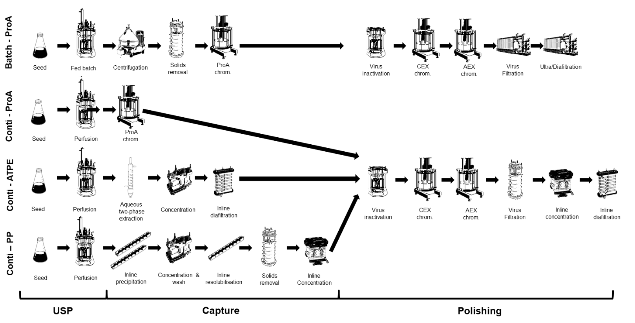
Figure 1 - Process flowsheets studied in batch and continuous production of monoclonal antibodies. ProA: protein A; CEX: cation exchange; AEX: anion exchange; TFF: tangential flow filtration; SP-TFF: Single-pass tangential flow filtration. Batch-ProA: batch mAb production with protein A as capture step; Conti-ProA: continuous mAb production with protein A chromatography as capture step; Conti-ATPE: continuous mAb production with aqueous two-phase extraction as capture step; Conti-PP: continuous mAb production with product precipitation as capture step.

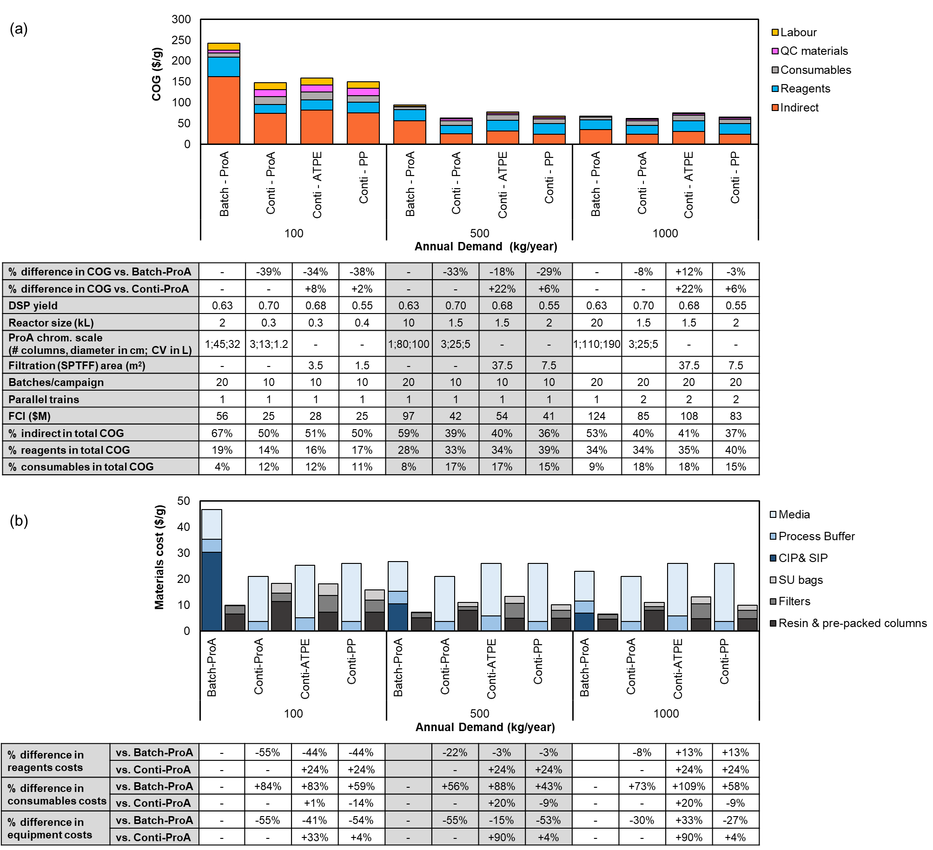

Figure 2 - Breakdown of (a) COG/g on a cost category basis and (b) materials (reagents and consumables) cost for four mAb production flowsheets at 100, 500 and 1000 kg/year commercial scales. The fed-batch flowsheet is integrated in a stainless-steel based facility, while the continuous flowsheets are single-use based. The titre for fed-batch culture is 5g/L and the perfusion volumetric productivities assumed in all continuous strategies was 3g/L/day. SU bags include both bioreactor bags and buffer hold bags. The embedded table in (a) indicates the key parameters for each batch and continuous facility and the percentage of indirect, reagents and consumables in each flowsheet’s COG/g. The embedded table in (b) presents the percentage difference in equipment, reagents and consumables costs between flowsheets.

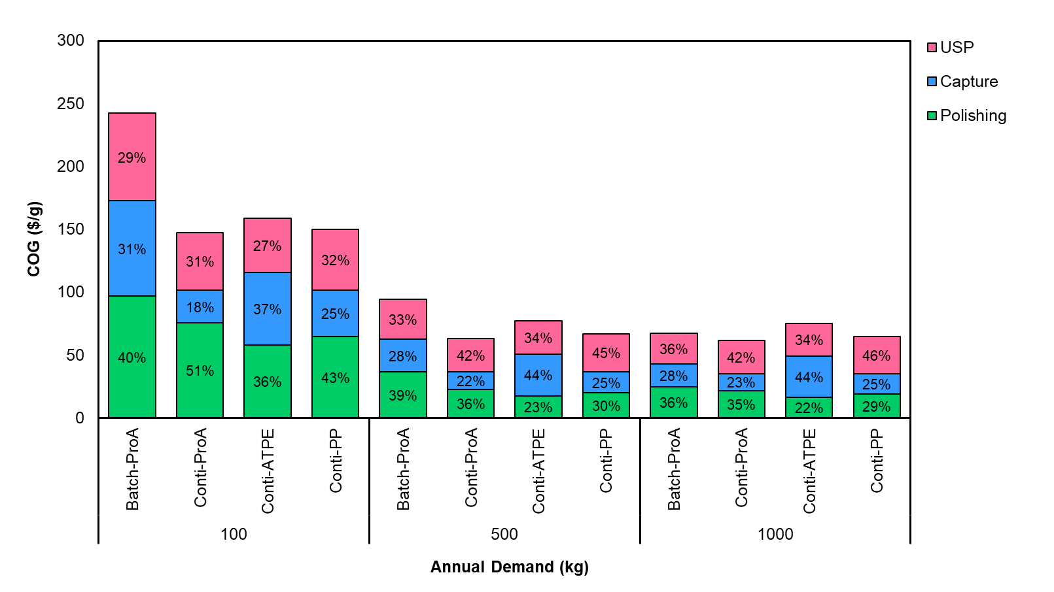
Figure 3 - Breakdown of COG/g per processing stage of four mAb production flowsheets. The COG breakdown on a process stage basis is showed for 100, 500 and 1000kg/year commercial scales, while the contribution of each process stage in each cost category is shown for the 500kg/year scale. USP and polishing steps are fixed among continuous flowsheets, while the capture stage comprises different unit operations.

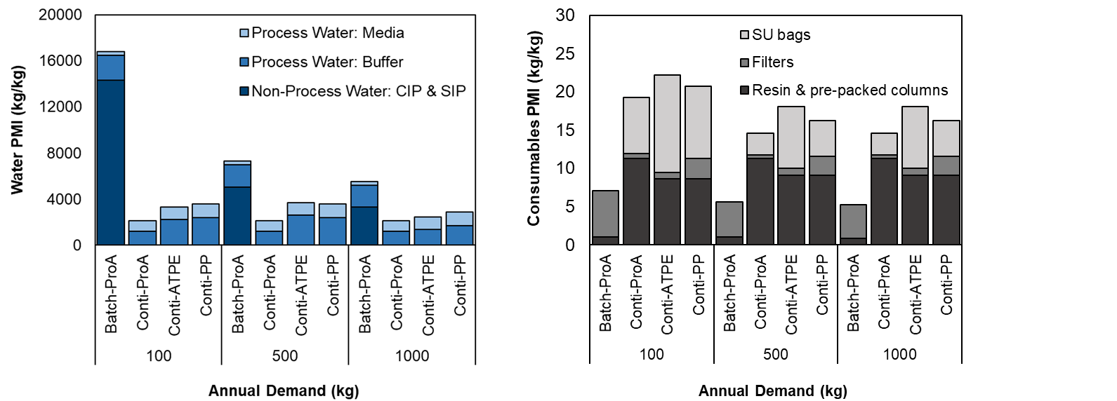

Figure 4 - Water and consumables process mass intensity (PMI) breakdown for four mAb production flowsheets at 100, 500 and 1000 kg/year commercial scales. The water and consumables PMIs include the complete production train liquid and solid waste, respectively. The consumables PMI is based on the total weight of individual disposable material (SU bags, filters, resin and pre-packed columns). The weight of each material was found in literature or given by suppliers. SU bags include both bioreactor bags and buffer hold bags.

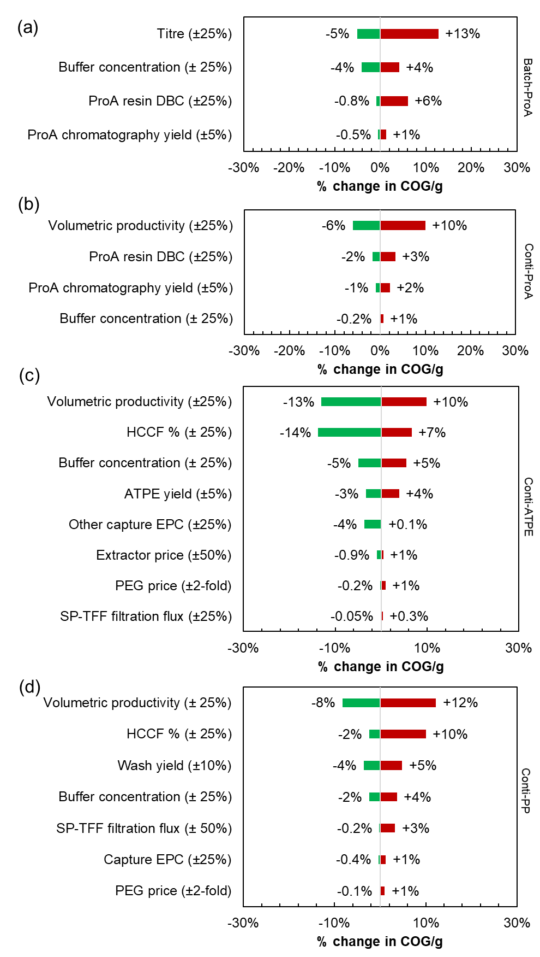
Figure 5 - Sensitivity analysis of COG/g showing the effect of process parameters variation on a) Batch-ProA, b) Conti-ProA, c) Conti-ATPE or d) Conti-PP mAb production flowsheets, at 500 kg/year scale. The percentage differences are relative to the COG/g in the base case.

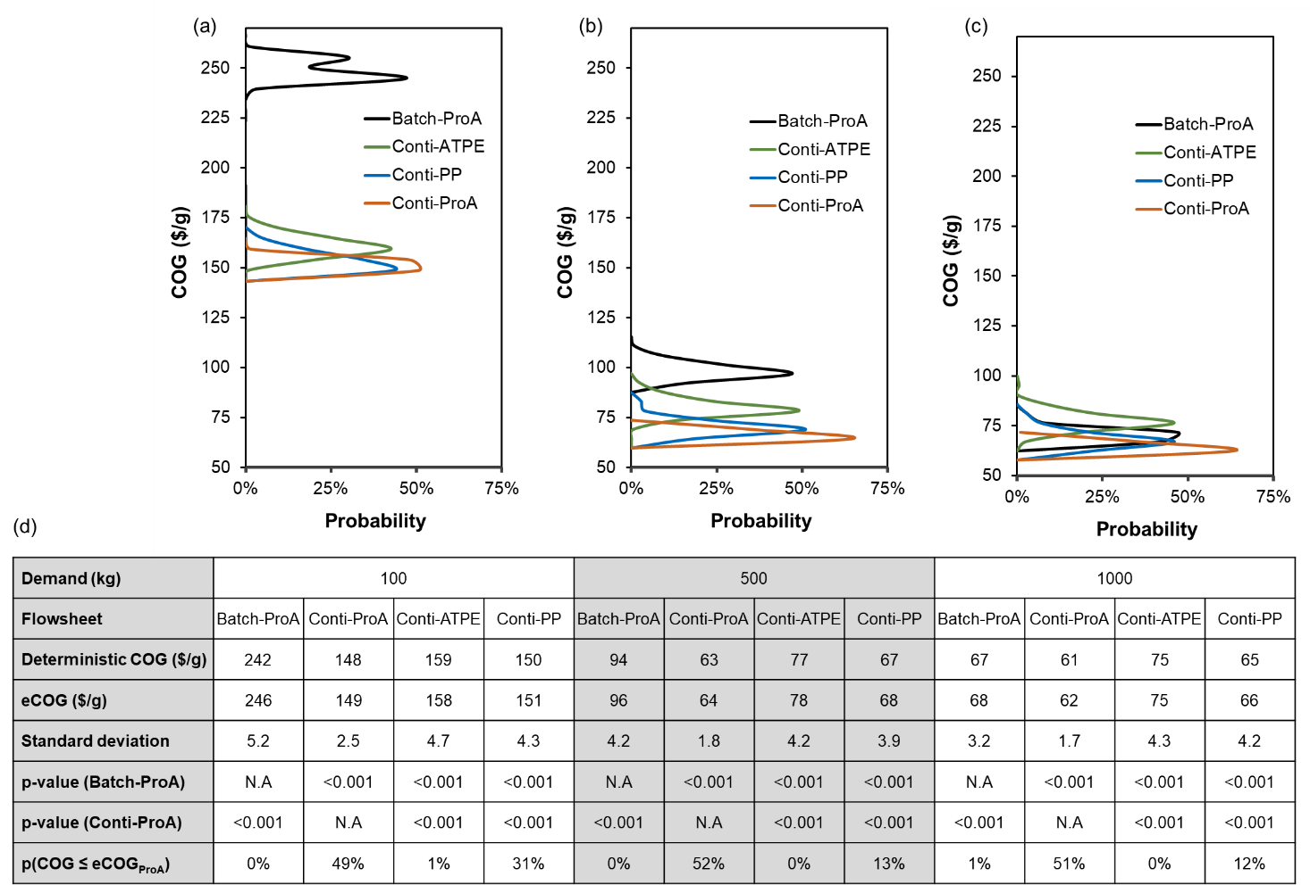

Figure 6 - COG/g probability distribution plots under manufacturing uncertainty at a) 100 kg/year, b) 5000 kg/year and c) 1000 kg/year production scales. d) Statistical data on COG/g for the competing technologies under process variability across demands. The p-values were computed using a two-tailed homoscedastic t-test with an alpha value of 0.05; p-values below this value indicate a significant difference. p-value (Batch-ProA) and p-value (Conti-ProA) refer to the values when the COG distributions from each flowsheet were compared with that of Batch-ProA and Conti-ProA, respectively. eCOG = expected COG.

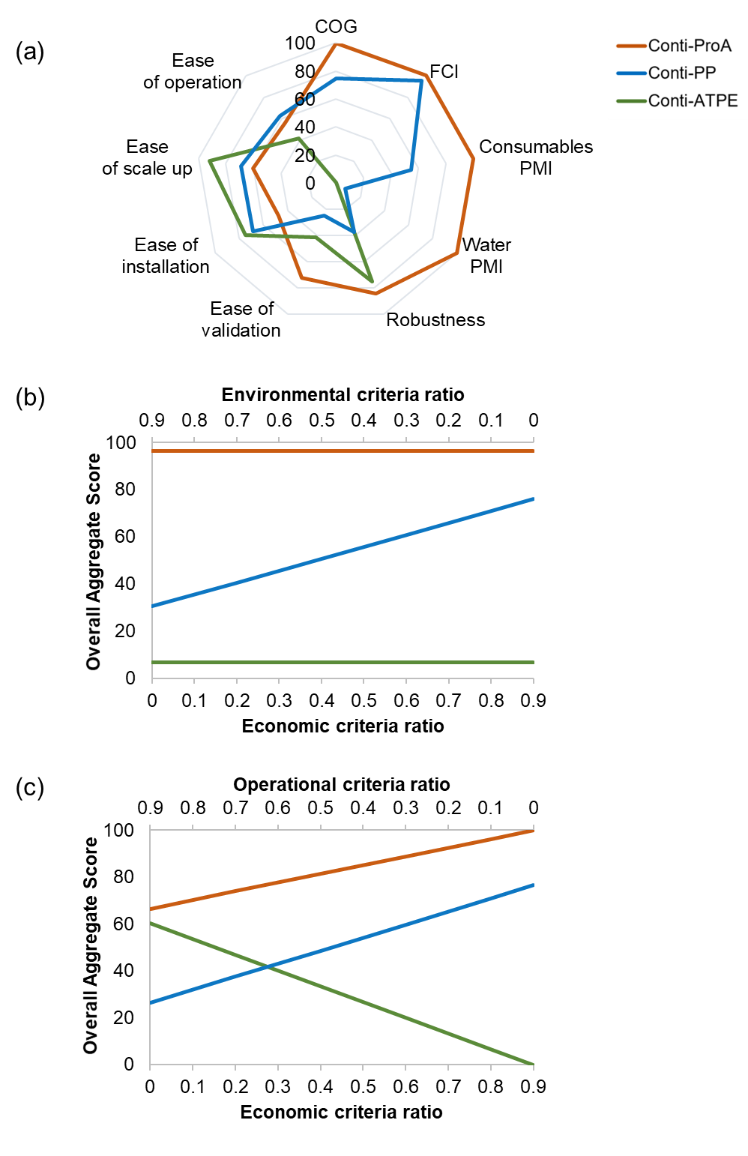
Figure 7 - a) Rating values of Conti-ProA, Conti-ATPE and Conti-PP flowsheets for each economic (Cost of Good – COG; Fixed Capital Investment – FCI), environmental (Consumables PMI; Water PMI) and operational (robustness, ease of operation, scale up, installation and validation) criteria. b and c) Effect of the economic, operational and environmental criteria combination ratios on the overall aggregate scores when the operational attribute ratio is constant at 10% (b) and when the environmental attribute ratio is constant at 10% (c). All graphs are generated for a mAb demand of 500 kg/year.

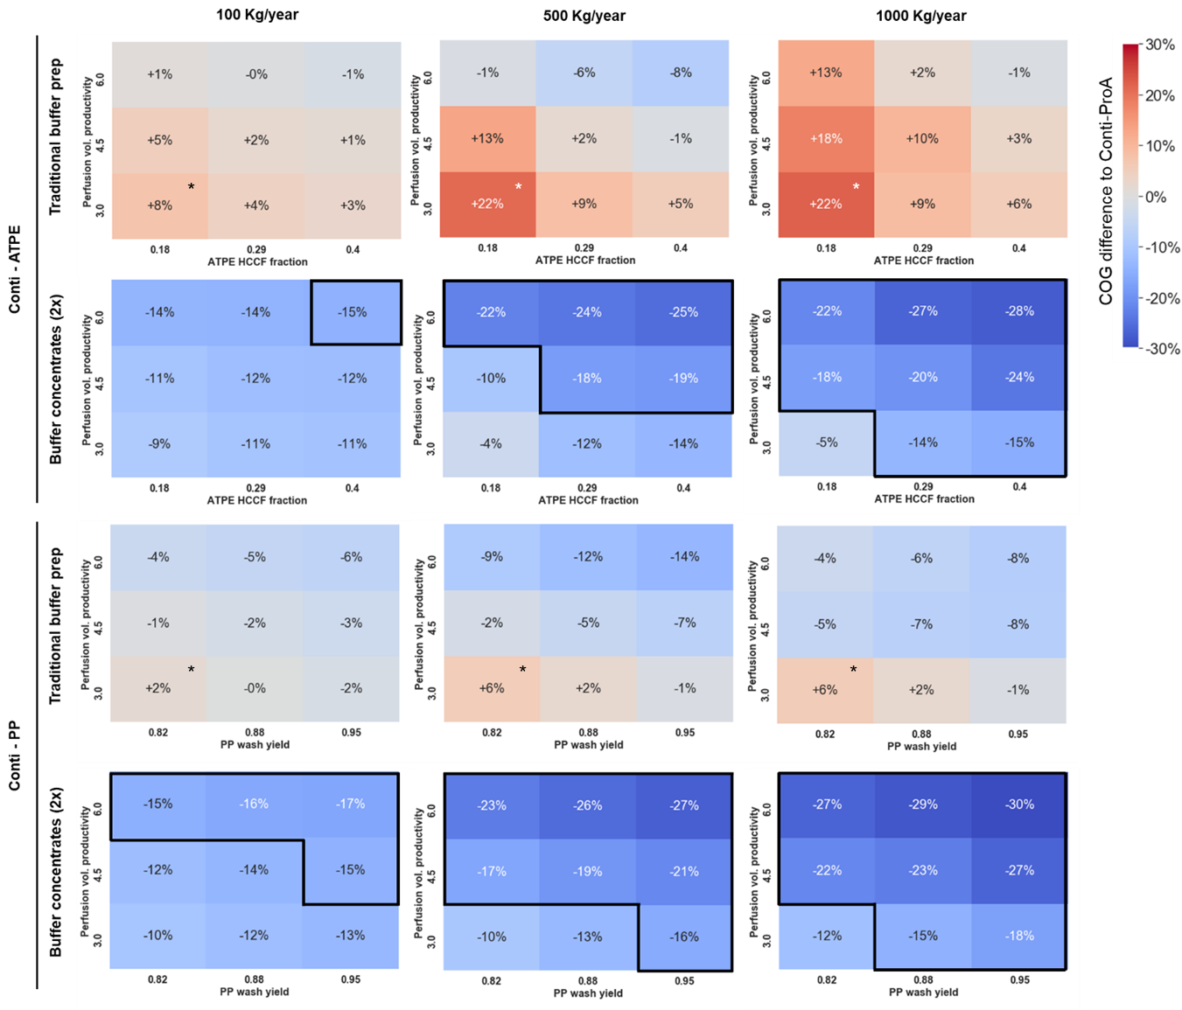
Figure 8 - Heat maps showing the COG difference for Conti-ATPE and Conti-PP relative to Conti-ProA as a function of the perfusion volumetric productivity versus either the HCCF% fraction for Conti-ATPE or the wash yield for Conti-PP. The target analysis is shown for scenarios using traditional buffer preparation as well as buffer concentrates. * indicates the base case scenario. The area within the solid black line indicates the conditions at which Conti-ATPE and Conti-PP present ≥15% COG/g savings compared to Conti-ProA.

SUPPLEMENTARY MATERIAL

Evaluating end-to-end continuous antibody manufacture with column-free capture alternatives from economic, environmental and robustness perspectives
Catarina P. G. Neves¹, Jonathan L. Coffman², Suzanne S. Farid^{1*}

¹The Advanced Centre for Biochemical Engineering, Department of Biochemical Engineering, University College London, Gower Street, London WC1E 6BT
²Bioprocess Technologies and Engineering, Biopharmaceuticals Development, R&D, AstraZeneca, Gaithersburg, USA

Cost and environmental equations and cost data used for calculating the cost of goods (COG/g) of batch and continuous flowsheets
The term Cost of Goods (COG) usually comprises 1) indirect and 2) direct manufacturing costs.
The indirect costs can be calculated through the fixed capital investment and include the depreciation of equipment, cost of general utilities, cost of maintaining and insuring the production facility and local taxes. The term of general utilities accounts for facility running cost, such as the HVAC systems used in the clean-rooms and depends on the facility size.
The direct costs are variable costs and include the expenditures on reagents, consumables, quality control materials and labor, depending on the amount of product manufactured. Reagents costs include all buffers (including cleaning buffers), media, water for injection and pure water required, while the consumables costs encompass the cost of chromatography resins, pre-packed columns, membrane filters and all single-use materials. Quality control materials account for the reagents and consumables used in quality control tests of produced batches. Labor costs represent the cost of direct labor and the cost of additional supervision, management and QCQA (quality control and quality assurance) personnel. The direct labor costs are estimated based on a fixed annual salary and yearly facility utilization, while the extra personnel expenses are derived based on this value.
The environmental burden caused by running a biomanufacturing facility is evaluated through the water and disposables consumption. Process mass intensities (PMIs) are calculated for each scenario across different product throughputs and, along with the economic metrics, help to compare alternatives for the production of monoclonal antibodies.
The water PMI is determined by summing up the quantities of all liquid reagents consumed in the process. On the other hand, consumables PMI is estimated based on the weights of all consumables. A wide range of materials weights was collected for different dimensions; however, when the required size was not part of the gathered list, the weight of the consumable with the closest size was assumed.
Table S1 summarizes the different equations used to compute direct and indirect costs and water and consumables PMI. Table S2 presents the individual cost data and assumptions used for the calculation of the fixed capital investment, direct costs and indirect costs. Table S3 shows the triangular distributions applied in the Monte Carlo simulations. Table S4 illustrates a sample of typical weights of consumables used in the PMI calculations. Table S5 shows the survey responses on the qualitative operational criteria rankings used for the multi-criteria decision making exercise.

Table S1 – Breakdown of cost of goods (COG) and process mass intensity (PMI) factors for a biomanufacturing facility.
COST METRICS
Fixed capital investment, $FCI$ ($) | $$FCI=L×\sum{C_{Equipment}}$$
Depreciation of equipment, $C_{Depr}$ ($) | $$FCI/t_{project}$$
General utilities, $C_{GenUt}$ ($) | $$F_{size}×F_{cost}$$
Maintenance,$C_{Mtn}$ ($) | $$0.1×FCI$$
Insurance, $C_{Ins}$ ($) | $$0.01×FCI$$
Local taxes, $C_{LocT}$ ($) | $$0.02×FCI$$
Indirect costs, $C_{indirect}$ ($) | $$C_{Depr}+C_{GenUt}+C_{Mtn}+C_{Ins}+C_{LocT}$$
Total labor costs, $C_{labor}$ ($) | $${C_{labor D}+ C_{labor S}+C_{labor M}+C_{labor QCQA} }_{}$$
Direct labor costs, $C_{labor D}$ ($) | $$N_{operators}×Salary×u$$
Supervisors costs, $C_{labor S}$ ($) | $$0.2×C_{labor D}$$
Management costs, $C_{labor M}$($) | $$C_{labor D}$$
QCQA staff costs, $C_{labor QCQA}$ ($) | $$C_{labor D}$$
Facility utilisation, $u$ (%) | $${t_{campaign}}/{365}$$
Number of operators, $N_{operators}$ | $$N_{opUSP}+N_{opDSP}$$
Number of USP operators, $N_{opUSP}$ | $${Shifts}_{USP/day}×N_{opUSP/shift}×\frac{N_{USP trains}}{{Train}_{USPteam}}×P_{trains}$$
Number of DSP operators, $N_{opDSP}$ | $${Shifts}_{\frac{DSP}{day}}×N_{\frac{opDSP}{shift}}×\frac{N_{USP trains}}{{Train}_{DSPteam}}×P_{trains}$$
Materials costs from QC tests, $C_{QC materials}$ ($) | $$N_{QC batches}×{Price}_{QC materials}$$
Direct costs, $C_{direct}$ ($) | $$C_{reagents}+C_{consumables}+C_{QC materials}+C_{labor}$$
Cost of goods per gram, $COG/g$ ($/g) | $$(C_{indirect}+C_{direct})/ Demand$$
ENVIRONMENTAL METRICS
Water PMI, ${PMI}_{water}$ (kg/kg) | $$m_{water}/Demand$$
Consumables PMI, ${PMI}_{cons}$ (kg/kg) | $$m_{cons}/Demand$$
Note:  $L$: Lang factor  ${Cost}_{Equipment}$: Equipment purchase cost ($)  $t_{project}$: Time of project (assumed 10 years)  $F_{size}$: Facility size (m²)  $F_{cost}$: Monetary units per sq. meters (assumed 525 $/m²)  $t_{campaign}$: Campaign running time (days)  $Demand$: Annual product demand (kg or g)  ${Shifts}_{USP/day or DSP/day}$: Shifts of USP/DSP per day  $N_{op/shift}$: Number of USP/DSP operators per shift | $N_{USP/DSP trains}$: Number of USP/DSP trains  ${Train}_{USP/DSPteam}$: Number of USP/DSP trains per team  $P_{trains}$: Product parallel trains  ${Price}_{materials}$: price of materials used in QC test ($)  $N_{QC batches}$: Number of cycles of final product out  $m_{water}$: Mass of water consumed per year (Kg)  $m_{cons}$: Mass of disposables consumed per year (Kg)

Table S2 – General cost data to calculate the fixed capital investment and cost of goods metrics.
 | Batch | Continuous
Facility | Stainless-steel based | Single-use based
Operational time | 340 days
USP operators per shift | 6
DSP operators per shift | 6
Shifts per day | 3
Annual Salary | 100 000 $
Lang factor | 8.13 | 4.75
Key equipment and consumables cost | Bioreactor (200L) = 240,000$  Hold-tank (500 L) = 40,000$  Centrifuge (600 L/h) = 430,000$  Chromatography column (D=60 cm) = 66,500$  Chromatography skid (3 L/min) = 160,000$  Filter housing (2 m²) = 3,500$  UFDF skid (20 m²) = 245,000$  Depth filter (1 m²) = 300 $  Virus removal membrane (1 m²) = 6,800$  UFDF membrane (1 m²) = 3,200$ | SU bioreactor container (500L) = 200,000$  Hold bags containers (500 L) = 7,000$  Chromatography skid (1.33 L/min) = 280,000$  ATPE extractor (D = 30 cm) = 66,500$  Precipitation static mixer (D = 0.48 cm) = 1,000$  SP-TFF skid (3.5 – 9 m²) = 850,000$  Bioreactor bags (500 L) = 5,100$  Hold bags (500 L) = 530$  ATF membrane (5 m²) = 10,300$  SP-TFF membrane (1 m²) = 4,243$  Empty chromatography column = 2,000$
Key materials cost | Protein A resin = 12,000 $/L  Cell culture media batch = 33 $/L  Cell culture media perfusion = 19 $/L  PEG 3350 = 2 $/L  CIP buffer = 3 $/L  QC materials cost = 35,000 $/test

Table S3 – Triangular distributions used in Monte Carlo simulations for the uncertainty analysis
Parameter | Distribution | Flowsheet
Fermentation titre (g/L) | Tr (3.75,5,6.25) | Batch-ProA
Perf. Volumetric productivity (g/L/day) | Tr (2.25, 3, 3.75) | Conti-ProA/ATPE/PP
ProA Dynamic binding capacity (g/L resin) | Tr (50, 65, 80) | Conti-ProA
ATPE yield | Tr (0.80, 0.85, 0.90) | Conti-ATPE
HCCF% ATPE | Tr (0.14, 0.18, 0.25) | Conti-ATPE
HCCF% PP | Tr (0.40, 0.50, 0.60) | Conti-PP
Wash yield | Tr (0.75,0.82, 0.90) | Conti-PP

Table S4 – Weights of consumables used for the PMI calculation.
Material | Example of weight & scale
SU bag | 7 Kg (2000 L)
Chromatography pre-packed column | 11Kg (4 L)
Depth filter | 5 Kg (2.5 m²)
Virus removal filter | 4 Kg (1 m²)
Inline concentration/diafiltration (ILC/ILD) membrane | 3 Kg (2.5 m²)
UFDF membrane | 2 Kg (1 m²)

Table S5 – Responses from operational criteria survey. R= respondent.
 |  | ProA v. ATPE |  |  |  |  |  | ProA v. Precipitation |  |  |  |  |  |  |  |  |  | AVG ProA | STD  ProA | AVG ATPE | STD  ATPE | AVG PP | STD  PP
 |  | R1 |  | R2 |  | R3 |  | R4 |  | R5 |  | R6 |  | R7 |  | R8
 |  | ProA | ATPE | ProA | ATPE | ProA | ATPE | ProA | PP | ProA | PP | ProA | PP | ProA | PP | ProA | PP
Rating value, $x_{ij}$ | Robustness | 5 | 3 | 3 | 5 | 5 | 4 | 5 | 2 | 5 | 2 | 4 | 5 | 3 | 1 | 5 | 4 | 4.4 | 0.9 | 4.0 | 1.0 | 2.5 | 1.7
 | Ease of validation | 4 | 3 | 4 | 3 | 4 | 2 | 5 | 1 | 3 | 1 | 3 | 5 | 3 | 1 | 5 | 4 | 3.9 | 1.1 | 2.7 | 0.6 | 2.0 | 2.0
 | Ease of installation | 3 | 4 | 2 | 5 | 1 | 3 | 4 | 4 | 4 | 3 | 3 | 5 | 2 | 3 | 5 | 4 | 2.9 | 1.1 | 4.0 | 1.0 | 3.8 | 1.0
 | Ease of operation | 4 | 3 | 4 | 4 | 2 | 1 | 4 | 3 | 2 | 4 | 2 | 5 | 3 | 2 | 5 | 3 | 3.3 | 1.3 | 2.7 | 1.5 | 3.5 | 1.3
 | Ease of scale up | 4 | 4 | 4 | 5 | 3 | 5 | 5 | 3 | 1 | 5 | 2 | 5 | 3 | 2 | 5 | 3 | 3.4 | 1.8 | 4.7 | 0.6 | 3.8 | 1.5
Weight, $E_{i}$ | Robustness | 5 |  | 3 |  | 5 |  | 5 |  | 5 |  | 5 |  | 5 |  | 4 |  | 5
 | Ease of validation | 4 |  | 5 |  | 3 |  | 2 |  | 2 |  | 4 |  | 4 |  | 3 |  | 3
 | Ease of installation | 2 |  | 1 |  | 2 |  | 1 |  | 1 |  | 1 |  | 1 |  | 2 |  | 1
 | Ease of operation | 4 |  | 2 |  | 1 |  | 3 |  | 4 |  | 2 |  | 2 |  | 1 |  | 2
 | Ease of scale up | 4 |  | 4 |  | 4 |  | 4 |  | 3 |  | 3 |  | 3 |  | 3 |  | 4
Note: A rating value of 5/5 represents the best outcome.

